The Rigid-Body Transform

Such a transform, consisting of concatenations of only translations and rotations, is called a rigid-body transform.It has the characteristic of preserving lengths, angles, and handedness.

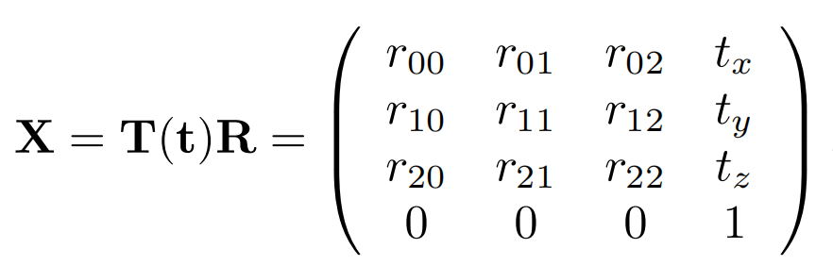

The inverse of X is computed as X-1 = (T(t)R)-1 = R-1T(t)-1 = RTT(-t).

A common task in graphics is to orient the camera so that it looks at a certain position.